

The 4-H Newsletter

Meet Your 4-H Agents!

Welcome aboard! We’re thrilled to have you join our crew of curious, creative, and courageous youth explorers. As your 4-H Agents, we’re here to guide you on a journey that’s out of this world—filled with discovery, leadership, friendship, and fun.
Whether you're launching into your first project or orbiting new challenges, 4-H is your mission control for learning and growth. From STEM, shooting sports, sewing, or cooking adventures to community service, livestock to leadership, your path is yours to chart—and we’re ready to help you soar. Whatever your interests, there’s a constellation of opportunities waiting for you!
So, buckle up, dream big, and get ready to go “To 4-H & Beyond!” The countdown has begun, and your 4-H journey is about to take off. Let’s make this year stellar!
All 3rd-12th grade students in St. James Parish are eligible to enroll in the St. James Parish 4-H program. All 3rd graders are encouraged to enroll in our FREE Cloverbud program that offers a unique experience to learn about the 4-H program and different program areas. Our 4th-12th graders can join the 4-H program by paying the required $5.00 fee to be enrolled.
How To Enroll:
To enroll in the St. James Parish 4-H program, you can either enroll directly on 4-H Online (www.v2.4honline.com) or complete the paper enrollment form and submit it to your child's school club leader or turn it in to the 4-H office. If you have any questions about enrollment, please contact the 4-H office at 225-562-2320 or the 4-H Agents - Carly Dufresne (cmboudreaux@agcenter.lsu.edu) or Laynie Smith (larceneaux@agcenter.lsu.edu).

St. James Parish September 2025



Calendar of Events
September
1: Labor Day Holiday
10: Jr. Leader Mtg, 6pm
18: Southeast Area Leader Training – LSU Mini Farm
17: Shooting Sports Parent Info Night – 6pm
21: Shooting Sports Field Day - St. James Sheriff’s Range

October
5-11: National 4-H Week
8: Mandatory Livestock Meeting, 6pm & Pet Show Entry Deadline
9: Jr. Leader Mtg. – 6pm
13-14: Cooking Club Kick-Off Camp
16: Sewing Club
22: Ag Day, Fast Food Farm
24: Paws for a Story Contest Due & Shooting Sports Registration Due
28: Party with the Pumpkins
30: Paint-A-Pumpkin Judging

Mrs. Carly
Mrs. Laynie
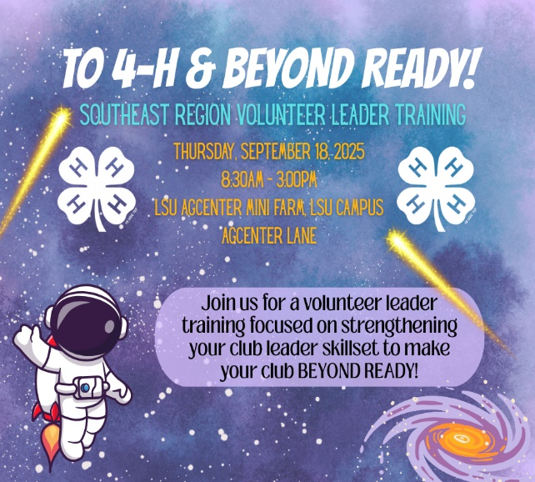

Volunteers
Volunteers are the heartbeat of St. James Parish 4-H. There are many roles and positions that provide important functions to help make 4-H programming happen! All volunteers must be registered in 4-H Online in order to serve as a 4-H volunteer. Individuals can volunteer to serve as project leaders, provide transportation to 4-H events, assist with parish or school 4-H programs, and more.
Volunteers and club leaders are welcome to join us at the Southeast Leader Training on Sep. 18th to gain the knowledge and skills to become successful volunteers.
If you are interested in volunteering with us, please call the 4-H office or contact Mrs. Carly or Mrs. Laynie. To learn more about volunteer roles please visit www.lsuagcenter.com/stjames/4h/volunteers

Jr. Leader Club

What is the Jr. Leader Club?
The Jr. Leader Club provides members with the opportunity to learn about the qualities needed to be a leader while participating in fun activities and events from the parish to the state level. This club focuses on developing leadership skills and giving back to the community. As a Junior Leader you can make an impact, while having fun and making life-long memories. Members are expected to assist with parish events year-round, fundraise and actively participate in the club. Meetings are held once a month at the 4-H office.

Who can join?
Jr. Leaders must be a 7th-12th 4-H member enrolled in 4-H Online. All 7th-12th grade At-Large members can join the Jr. Leader Club as well.

Ice Scream Social
Join us September 10th at 6pm for our first Jr. Leader of the year at the 4-H office for an ice cream social! All 7th-12th graders are welcome to attend. The cost to join the Jr. Leader Club is $10. Everyone who pays their $10 Jr. Leader Fee by the next meeting on October 10th, will be in the running to win a $25 gift card.

4-H Blessing Box Hygiene Drive
The Months of September and October

4-H is collecting hygiene items for our four Blessing Boxes across the parish. 4-H members and school clubs may collect items like shampoo, soap, toothbrushes, toothpaste, deodorant, etc. to be turned into the 4-H office. The school club that donates the most items will receive a treat at their November club meeting.





Livestock Program
Interested in joining the 4-H livestock program? 4-H members ages 9-18 are eligible to show livestock. The Livestock program is one of our largest programs teaching youth lifelong skills including teamwork, responsibility, belonging and much more!
St. James Parish Poultry & Rabbit Show: January 16, 2026
St. James Parish Livestock Show: January 23-24, 2026
Southeast District Livestock Show: January 28-31, 2026
LSU AgCenter State Livestock Show: February 14-21, 2026
Mandatory Livestock Meeting
Wednesday, October 8, 2025 – 6:00pm – PR Building (LHS)
Deadline dates, show rules, 4-H Online, Fair Entry and more will be discussed at the annual mandatory livestock meeting. If you are a new livestock member or a returning member, please make every effort to attend. Parents/Guardians should be in attendance with their livestock exhibitor at the meeting.
Please email Carly (cmboudreaux@agcenter.lsu.edu) if you have any questions.

Market/Commercial Deadlines:
November 10, 2025
Beef & Dairy Commercial Heifers, Market Lambs & Commercial Ewes, Market goats & Commercial Does: Must be validated by exhibitor and submitted to the St. James Parish Extension Office by 4:30 p.m. Must also be uploaded in 4-H Online.
December 1, 2025
Market & Commercial Hogs: Must be validated by exhibitor and submitted to the St. James Parish Extension Office by 4:30 p.m. Must also be uploaded in 4-H Online.
Breeding Possession Deadlines:
Breeding animals must be in EXHIBITORS’S name and uploaded in 4-H Online by 4:30pm on the dates below.

November 10, 2025
Beef, Sheep, Goats, Dairy Breeding & Exhib. Poultry
November 17, 2025
Miniature Cattle
December 1, 2025
Swine Breeding
Parish Livestock Ambassadors
The St. James Parish 4-H Livestock Ambassador program provides an opportunity for 4-H youth in grades 8th to 12th to be empowered with knowledge of the livestock industry in order to serve as strong advocates for agriculture, mentors for younger 4-H members with livestock projects, and consumer educators in the importance of agricultural across our parish and state.

Requirements:
- 8th-12th grade 4-H member.
- Has shown livestock for at least 1 year.
- Must be a good standing 4-H member for 2 years plus.
Opportunities:
- Participate in farm tours
- Lead clinics and mentor youth
- Assist at Livestock Shows
- Gain hands-on experience with livestock

Contact the 4-H office or email Mrs. Carly at cmboudreaux@agcenter.lsu.edu for an application.
Deadline to apply: September 19, 2025

Shooting Sports Program
The St. James Parish 4-H Shooting Sports Club is very excited to begin this year’s activities! All participants must be a member of St. James Parish 4-H school club or a 4-H member-at-large. So, enrolling in 4-H Online is your first step.
St. James 4-H Shooting Sports Parent Meeting | Wednesday, September 17th
4-H Office – 6pm
*Mandatory for new members joining.* Join us for an informational meeting where we discuss youth and parent roles, practices, competitions and more in the Shooting Sports Program.

St. James 4-H Shooting Sports Field Day | Sunday, September 21st
9am-12pm
St. James Parish Sheriff’s Shooting Range
29449 Sheriff Range Rd, Vacherie, LA 70090
A day of program information and practice to discover what discipline you may be interested in. 4-Hers will be able to speak with coaches, former members and complete their registration for Shooting Sports. Disciplines offered: Archery, BB Gun, Air Pistol, Air Rifle, Smallbore Rifle, Smallbore Pistol and Shotgun. Registration Deadline: October 24th.
Please call the 4-H Office at 225-562-2320 or email your information to Mrs. Laynie at larceneaux@agcenter.lsu.edu to sign up for Shooting Sports.
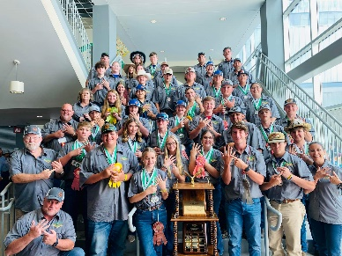

National 4-H Week: October 5-11, 2025
National 4-H Week will be celebrated October 5-11, 2025. We challenge each of our school clubs to show your 4-H spirit by decorating your school halls and yard in the 4-H colors: green and white. Each school can choose a theme by incorporating the 4-H colors or simply just decorate to show their spirit!
School Spirit Judging – Friday, Oct. 10th
Decorate your school halls & yard by incorporating the National 4-H Colors: Green and White! Mrs. Carly and Mrs. Laynie will come by the schools to judge decorations.
National Character Counts Week: October 20-26, 2025

Bumper Sticker & Bookmark Contest
- Bumper Stickers must be 11 inches long and 3 inches wide
- Bookmarks must be 8 inches long and 2 inches wide
- Draw your bumper sticker or bookmark (entries must be in color)
- Choose One Pillar of Character
- Add your message or slogan.
- Be neat and spell words correctly. No glue or tape can be used.
- Include your name, grade, and school on the back.
Mrs. Carly and Mrs. Laynie will collect your entries from your club leader, or you may turn them in to the 4-H office by Friday, November 14th.


4-H Party with the Pumpkins
Tuesday, October 28, 2025, | Lutcher Park | 4:30pm-6:30pm
15th Annual Safe Trick or Treating
Come in COSTUME to Trick-Or-Treat around Lutcher Park Pavilion from all local businesses in St. James Parish and the surrounding areas!

- Event parking is available along the street and local lots.
- NO Parking in the Lutcher Park Lot.
To get your Business/Organization Involved – Call 225-562-2320

Paint-A-Pumpkin Contest
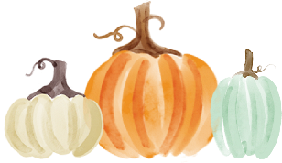
It’s time to go to the pumpkin patch! Our annual Paint-A-Pumpkin Contest Judging will take place on Thursday, October 30, 2025. Pumpkins will be brought to school on this day to be judged. Club leaders will inform you on where to drop off your pumpkins.
Contest Rules:
- Real pumpkins only.
- Painted pumpkins only. No carved pumpkins.
- Stickers, paper, pipe cleaners, etc. may be added.
- NO glitter!
- You may only enter ONLY 1 pumpkin in 1 of the categories below for judging.
- You may NOT submit more than one pumpkin in the contest.
- Each entry will receive a Blue, Red or White ribbon.
- 4-Hers will select one of the following categories to enter their pumpkin in:
  - Scariest Pumpkin
  - Funniest Pumpkin
  - Most Original
  - Most 4-H Spirit
- An Overall Winner for each Category will be chosen for each division.
  - Divisions: Cloverbud (3rd), Elementary (4th-6th), Jr. (7th-8th), and Sr. (9th-12th)
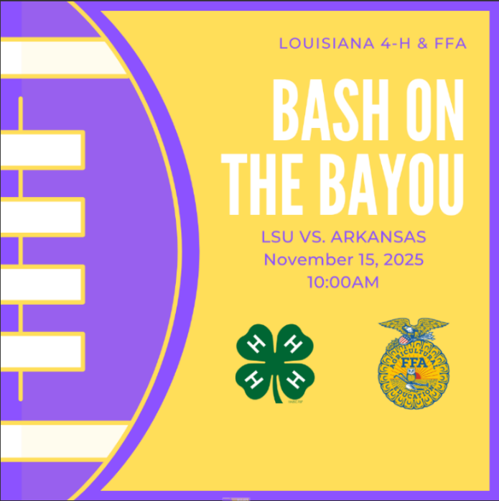
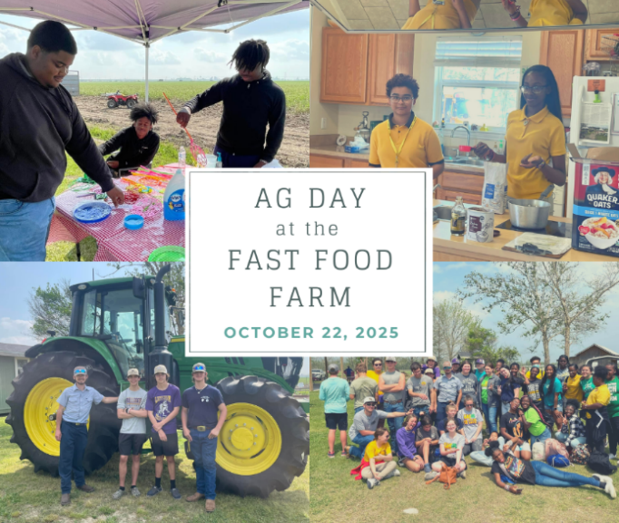
Sewing Club
Our first Sewing Club Meeting is on October 16th from 5pm to 7pm at the 4-H office. Meetings will be held once a month all year long. This project club is for beginners and experienced youth in hand sewing and using a sewing machine. Members will be able to make several items that can be used and taken home each month.
Who can join? 4th-6th grade 4-H members



How to Register: The registration fee is $10. The registration form can be found by scanning the QR code below. Payment will be accepted in the form of cash or check and must be turned into the 4-H office. The registration form MUST be completed and payment MUST be received in order to be registered. Spots are LIMITED! No materials are needed for the first meeting.
If you have any questions, please contact
Mrs. Carly at cmboudreaux@agcenter.lsu.edu.

Scan the QR Code to Register

Cooking Club & Kick Off Camp
Join us at our official kick off to Cooking Club on October 13th and 14th from 9AM – 2:30 PM at the 4-H office. Follow up cooking club meetings will be held in the fall on November 5 and December 10 from 5 pm – 6:30 pm. Our Cooking Club will be a great experience for beginners and for our intermediate little chefs to learn new skills, taste their delicious creations, and build friendships!
Who can join? 4th-6th grade 4-H members


How to Register: There is a $10 registration fee, and spots are LIMITED! Payment must be delivered to the 4-H office (check or cash only). You must complete the registration form by clicking the link below or scanning the QR code below and pay the $10 fee by October 8th to be registered.
If you have any questions, please contact
Mrs. Laynie at larceneaux@agcenter.lsu.edu.
Scan the QR Code to Register


Welcome Back 4-Hers!
Carly Boudreaux
Assistant Extension Agent
cmboudreaux@agcenter.lsu.edu

2204 S. Albert Street
Lutcher, LA 70071
(225) 562-2320
ADA: If you need a special accommodation for your participation in the event, please contact the office at 225-562-2320 at least two weeks prior to the event.
EEO: The LSU AgCenter is a statewide campus of the LSU System and provides equal opportunities in programs and employment.
Challenge Camp
Get ready for a spooktacular adventure at the Southeast Region Challenge Camp November 11-12th at the Lion King Retreat Center in Amite, LA. Join us at Challenge Camp to test your team building and leadership skills with 4-Hers from across the Southeast Region. You won't want to miss out on this awesome opportunity!

Who can attend?
- 7th & 8th Grade 4-H members
- 4 Girls & 3 Boys

What’s included?
- Transportation
- Housing
- Camp T-shirt

Talent Contest and Creative Costume Contest open to all attendees!
COST: $60 REGISTRATION DEADLINE: October 15th


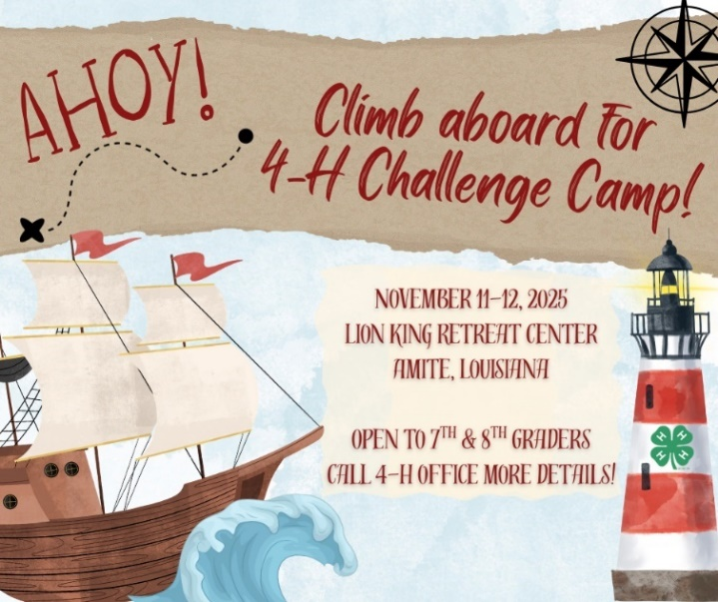



Welcome Back 4-Hers!
Carly Dufresne Laynie Smith
Associate Extension Agent Associate Extension Agent
cmboudreaux@agcenter.lsu.edu larceneaux@agcenter.lsu.edu

2204 S. Albert Street
Lutcher, LA 70071
(225) 562-2320

ADA: If you need a special accommodation for your participation in the event, please contact the office at 225-562-2320 at least two weeks prior to the event.
EEO: The LSU AgCenter is a statewide campus of the LSU System and provides equal opportunities in programs and employment.

